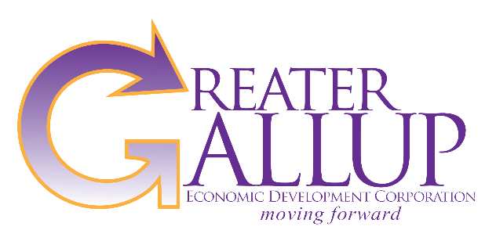
For Immediate Release | Contact: Patricia Lundstrom, CEcD  Executive Director
 | Phone: 505.722.2980
Email: patty@gallupedc.com
Website: www.gallupedc.com

GGEDC awarded TBIC FDI Certification

TBIC and Navigator Consulting announced GGEDC is among the first eight in the U.S. to receive the Foreign Direct Investment Qualified Community Certification

Gallup, NM — GGEDC Board President Tommy Haws announced Trans-Atlantic Business Council (TBIC) is awarding the Foreign Direct Investment Qualified Community Certification (FDI Certification) to Greater Gallup Economic Development Corporation (GGEDC) with the purpose of promoting the Gallup-McKinley County market to foreign, specifically, European industries.

Trans-Atlantic Business Council seeks to connect European industrial enterprises with American communities in efforts to develop distant yet promising economies. “With the FDI community certification, TBIC will market Gallup-McKinley County to European manufacturing firms” said Executive Director Patty Lundstrom. “The FDI community certification indicates that Gallup-McKinley County has the necessary education infrastructure, talent pool, community support and existing base of manufacturers to support new manufacturing.”

FDI Certification involved a four stage review conducted over the course of six weeks involving development of a comprehensive community data set, responding to a sample request for information, 2-day community site visit, and community workshop.

The FDI Certification compliments GGEDC’s asset based economic development strategy which seeks economic growth by growing employment sectors such as logistics, distribution and warehousing, and manufacturing which rely on transportation assets such as rail and truck.
With FDI Certification, GGEDC will work closely with TBIC on FDI marketing efforts including possible attendance at European trade shows on manufacturing.

GGEDC receives $25,000 grant for business recruitment
Gallup, NM – Greater Gallup Economic Development Corporation (GGEDC) announced it has been selected for a $25,000 grant from the NM Economic Development Department and its LEADS grant program to fund business recruitment and attraction efforts for Gallup-McKinley County. GGEDC is one of only three applicant organizations to receive full funding.

Grant funds will allow GGEDC to participate in national and international trade shows in support of the recently obtain FDI community certification, and visit national business site selectors targeting the sectors of logistics and supply chain, manufacturing, warehousing and distribution, and energy.

“Attendance at strategic FDI trade shows and focused outreach with influential site selectors puts GGEDC in front of businesses looking to expand into the U.S.”, said Executive Director Patty Lundstrom. “With the FDI community certification and our LEADS grant, GGEDC will be able to market McKinley County to the world”.




